Sprint Two Report
portfolio task 6
Unit code: EAT40006
Unit Name: Engineering Technology Project B
Submission date: 21/09/2025

Acknowledgment of Country
Each team member identifies the Traditional Owners of the land they lived on while completing this work.
- Senupama Damdini Deshapriya acknowledges the Wurundjeri Woi Wurrung people as the Traditional Owners of the land they lived on while completing this work in Melbourne, Victoria.
- Chrishelle Anthoneyz acknowledges the Wurundjeri Woi Wurrung people as the Traditional Owners of the land they lived on while completing this work in Melbourne, Victoria.
- Haritha Manuja Perera acknowledges the Wurundjeri Woi Wurrung people as the Traditional Owners of the land they lived on while completing this work in Melbourne, Victoria.
- Thenura Dulnath Kuruppuarachchi acknowledges the Wurundjeri Woi Wurrung people as the Traditional Owners of the land they lived on while completing this work in Melbourne, Victoria.

Contribution summary (This Sprint)

 | Contribution | Initiatives | Communication |  |  |  |  |  | Respect
Team Member | Finished tasks in time or on time with an acceptable quality | Self-assigned tasks and proactively found solutions to problems | Attended all team meetings | Attended all supervisor meetings |  | Attended all client meetings | Replied every time within an acceptable timeframe | Kept the team updated about the status | The student respected others and listened to different opinions
Thenura Kuruppuarachchi | Yes-rebuilt the modifications in the pipeline and drainage systems with accuracy and usability as the focal points. | Yes- coordinated and troubleshot modelling problems, actively owning and engaging in the integration of tasks. | Yes |  | Yes | Yes | Yes | Yes | Yes
Haritha Perera | Yes- completed animations for the entire model, finalised phase 3 and reconciled the logic with composting. | Yes-recognised the opportunity to load phase 3 animations and worked on editing movement trails and sequences. | Yes |  | Yes | Yes | Yes | Yes | Yes
Senupama Deshapriya | Yes- phase 1 was the focus and the technician colour coded each compartment within the phase to show the different layers / stages to composting. | Yes-assisted with researching pipeline systems and helped to verify the accurate/ideal solution was implemented into the design process. | Yes |  | Yes | Yes | Yes | Yes | Yes
Chrishelle Anthoneyz | Yes- remodeled phase 1 and the base structure to reflect the revised dimensions of the plan and improve functionality. | Yes- added hinges with rotating moments to improve realism and strategically lay ground work for digitalizing related tasks or moments within future sprints. | Yes |  | Yes | Yes | Yes | Yes | Yes

Contribution Details (This Sprint)

Haritha Perera
Haritha concentrated on the animation aspect of the project. He completed the paddle behavior by ensuring it provides proper rotation, conducts lid movement, and engages specified instruction for the composting logic. Haritha also got started on integrating the airflow and condensation animations, laying the groundwork to have directional arrows in a subsequent sprint. Haritha also modelled Phase 3 (the collection chamber) with his animations acting as a parallel anchor for structural adjustments. All of his contributions provided added realism and usability, making the demo model significantly more robust at this point.
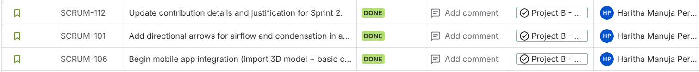
Thenura Kuruppuarachchi
Thenura performed the duties of a Scrum Master, facilitating the sprint to make certain that we were progressing in sync with reports and standards. He re-built the structure by repairing corrupted files, adding the transparent walls, and inserting lids and labels correctly. He also added piping and the outlets for condensate drainage, ensuring that all drainage logic was correct for the hardware. In addition to modeling, he researched water tank systems and assisted with general integration and communication across the team to facilitate fitting pitched components together seamlessly.
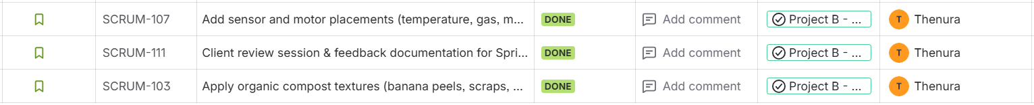
Chrishelle Anthoneyz
Chrishelle worked on providing structural accuracy to the model. She verified that measurements were not omitted, worked to the existing drawings to re-build the base structure for Phase 1 as well as confirm that each chamber dimension aligns with expectations as designed with the client. She modelled the hinges for Phase 1 with the correct axis of rotation. She contributed to Phase 2 visuals (which include the improved transparent graphics and labeling). Chrishelle maintained consistent documentation across the project by continually updating Jira tasks and records to keep the evolving model in alignment with deliverables.
Senupama Deshapriya
Senupama directed the design and research for the pipeline system, determining the configurations for condensation and air movement patterns. She ran models of pipelines to position them appropriately within the chamber layout, investigated the handling of drainage with the water tank model, and aided in the Phase 2 development of the project by assembling the components for the chamber with transparency and labelling as guiding principles for clarity. She made significant contributions through her skills in organic textures and visual representations of compost while ensuring the chambers (red, green, blue) were functional and easy to process.

sprint plan
This document can be considered as a continuation of the last sprint report, which ran from week 1 to week 3. In this section, the teams need to provide a detailed sprint backlog, along with estimation for this sprint (week 4 to week 6). The roles (specifically the scrum master) should be specified for this sprint, and the overall goal of the sprint should be discussed. As part of the sprint, if you plan to develop any artifact (module of application, any other documentation such as test plan, user document, etc), please list all those, and those should be submitted as an attachment to this report.]
Sprint Goal:
The goal for Sprint 2 (Weeks 4–6) was to enhance the LIDA composter model with a focus on drainage system realism, sensor integration, animation improvements, and app export readiness. The sprint aimed to address client feedback from Sprint 1, produce an updated 3D model in both realistic and transparent formats, and lay the foundation for mobile application integration by preparing GLB exports and UI mock-upsion for app integration, while maintaining both realistic and transparent model versions.
Scrum Master: Thenura Kuruppuarachchi
Team Approach:
The sprint was run using the Scrum methodology, with weekly facilitator meetings, client check-ins through Ms Teams, and backlog tracking in Jira. Each member self-assigned tasks but collaborated closely when dependencies arose (e.g., pipeline alignment requiring animation adjustments). Daily communication took place via WhatsApp group chat, and updates were logged in Jira to ensure transparency.
Backlog Summary (Week 4–6)
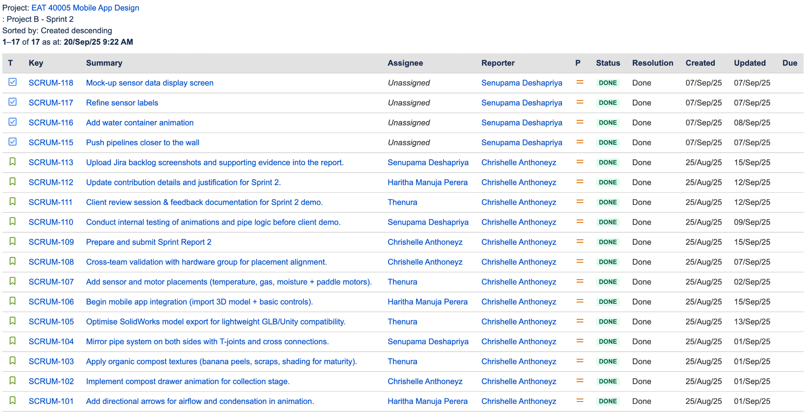
Figure 1.1 Backlog
The Jira backlog for Sprint 2 demonstrates that the team successfully completed all 17 planned tasks within the sprint cycle. Each task was created at the beginning of the sprint (25 August 2025) and was tracked through to completion. The backlog items cover a wide range of activities, including technical model updates, animation improvements, sensor integration, app export preparation, and report documentation.
The screenshot shows tasks such as pushing pipelines closer to the wall (SCRUM-115), adding a water container animation (SCRUM-116), and refining sensor labels (SCRUM-117), which were linked directly to client feedback from meetings in early September. These refinements ensured that the model met both functional and aesthetic expectations. Tasks like optimising SolidWorks model exports (SCRUM-105) and beginning mobile app integration (SCRUM-106) highlight the technical progress towards preparing the model for GLB compatibility and eventual app integration.
Administrative and documentation-related tasks were also tracked in Jira, such as uploading Jira backlog evidence (SCRUM-113), updating contribution details (SCRUM-112), and preparing and submitting Sprint Report 2 (SCRUM-109). While the technical tasks were completed by the official sprint end date of 14 September, some of these reporting-related backlog items were finalised slightly later, during the mid-semester break, to align with the report submission deadline of 21 September.
Overall, the backlog reflects a balanced workload across the team. Assignments were distributed among members with Senupama focusing on pipelines, water container animation, and sensor labelling; Haritha leading airflow animations and app integration; Thenura coordinating as Scrum Master while handling structural tasks and textures; and Chrishelle managing structural accuracy, report preparation, and hardware alignment. The status column shows all tasks as “Done”, confirming that Sprint 2 was fully deliverable, with every planned backlog item completed.

quality management plan and outcome
At this stage, we have the majority of the solution developed, it is a good time to finalize the quality management plan. This section should include the details of any quality management activities undertaken already and all that are planned. Please note that a good quality management plan should not only state the goal, but also detail how to assess whether the goal has been met or not. This can be incomplete work; however, please include the results of the testing that has been done already and the tests that are planned for the future.
At this stage of the project, the majority of the solution has been developed, making it an appropriate time to formalise a quality management plan. The overarching quality goals for the LIDA composter model and its integration into the mobile application are centred on accuracy, realism, clarity, and usability. Specifically, the 3D model must reflect the correct dimensions and placements agreed with the client, animations such as the compost drawer, paddle rotation, water tank, and airflow must operate smoothly and realistically, and the drainage system must convincingly demonstrate a tap-based mechanism without leaks or inconsistencies. Visual clarity is another essential objective, with sketch lines reduced to ensure a professional appearance while maintaining both a transparent version for educational use and a realistic version for functional demonstrations. In addition, export readiness for GLB files is a major benchmark, as the model must be fully compatible with the mobile app. Finally, all sensors and labels must align consistently with the UI mock-ups so that live data values can be displayed accurately in the application.
To achieve these goals, the team has already undertaken a range of quality assurance activities during Sprint 2. Peer reviews were conducted on SolidWorks assemblies to check for dimensional consistency and modelling errors, while internal testing focused on animations to confirm smooth drawer operation, paddle movement, and airflow arrows. Client feedback was incorporated into each iteration, with changes such as replacing the knob drainage system with a tap, pushing pipelines closer to the walls, and refining sensor labels being implemented promptly. Validation with the hardware group ensured that placements of pipelines and sensors were realistic and would align with the eventual physical integration of components. Export testing was also initiated, with preliminary GLB files successfully generated and trialled for compatibility with Flutter, although full app testing is still pending.
Planned quality activities for the next sprint will extend this focus further. Once permissions are granted, GLB file exports will be tested directly within the mobile application across different platforms to confirm performance and reliability. Simulated sensor values for temperature, gas, and moisture will be tested in the UI mock-ups to verify that the interface accurately displays live data in real time. Usability testing will also be conducted to evaluate whether the transparent and realistic model variants each communicate their intended functionality clearly to different stakeholders. In parallel, the user manual and technical handover documentation will be reviewed and incrementally updated to ensure that future developers and users can operate the system responsibly and without ambiguity.
Quality will be measured by several key indicators. Successful client acceptance in demonstrations will confirm that design and functionality standards have been met, while animation smoothness and visual clarity will serve as internal metrics for technical excellence. Export reliability will be judged by the ability of GLB files to run consistently across mobile devices, and consistency between sensor labelling in the 3D model and UI will ensure functional correctness.
The outcomes of Sprint 2 already indicate significant progress toward these goals. The tap-based drainage mechanism has been validated as practical, the water container animation has been added successfully, pipelines have been refined for alignment, and sensor labels have been improved for clarity. Transparent pipes and airflow animations have also been demonstrated to the client with positive feedback. However, some elements remain incomplete: app integration tests are delayed due to access permissions, and documentation requires further development before handover. Nevertheless, the structured approach taken in this quality management plan provides a strong foundation for achieving high-quality deliverables in Sprint 3 and beyond.

sprint progress
Sprint 2 continued the build from Sprint 1 and delivered the core mechanical detailing and motion
Pipeline System & Tank (Thenura)
- Modelled and placed the pipeline network and water tank, aligning routes to chambers and ensuring clearance for moving parts.
- Resolved connections and drainage logic consistent with the tap-based mechanism.
Lids & Chamber Corrections (Thenura)
- Repaired alignment, hinges and seals for chamber lids after earlier file issues.
- Prepared both transparent and realistic model variants for reviews.
Measurements / Phase 1 & Phase 2 Modelling (Chrishelle)
- Verified measurements against client drawings and rebuilt critical structures.
- Completed Phase 1 base and Phase 2 chamber assemblies to spec, ready for motion/integration.
Phase 3 Modelling & Motors (Senupama)
- Integrated motors into the model with correct constraints for rotation/drive.
- Designed and assembled the Phase 3 compost drawer mechanism; validated the full slide travel and interference clearances.
Animations & Movements (Haritha)
- Produced and refined movement sequences: paddle mixing, lid actuation and coordinated mechanism timing.
- Smoothed motion curves and synchronised sequences to match expected physical behaviour.
Documentation & Tools (Team)
- Kept Jira up to date; captured meeting minutes and evidence for the report.
- Prepared exports and repository structure for animation files and model variants.
Testing (Team)
- Ran internal motion checks (paddle, lids, Phase 3 drawer) and interference tests on assemblies.
- Conducted dry-runs for the client demo; incorporated feedback into the model variants.

This section describes the progress of the sprint with relevant evidence (e.g., screenshots of the repository, task board, etc). The evidence can be discussed with the supervisor.
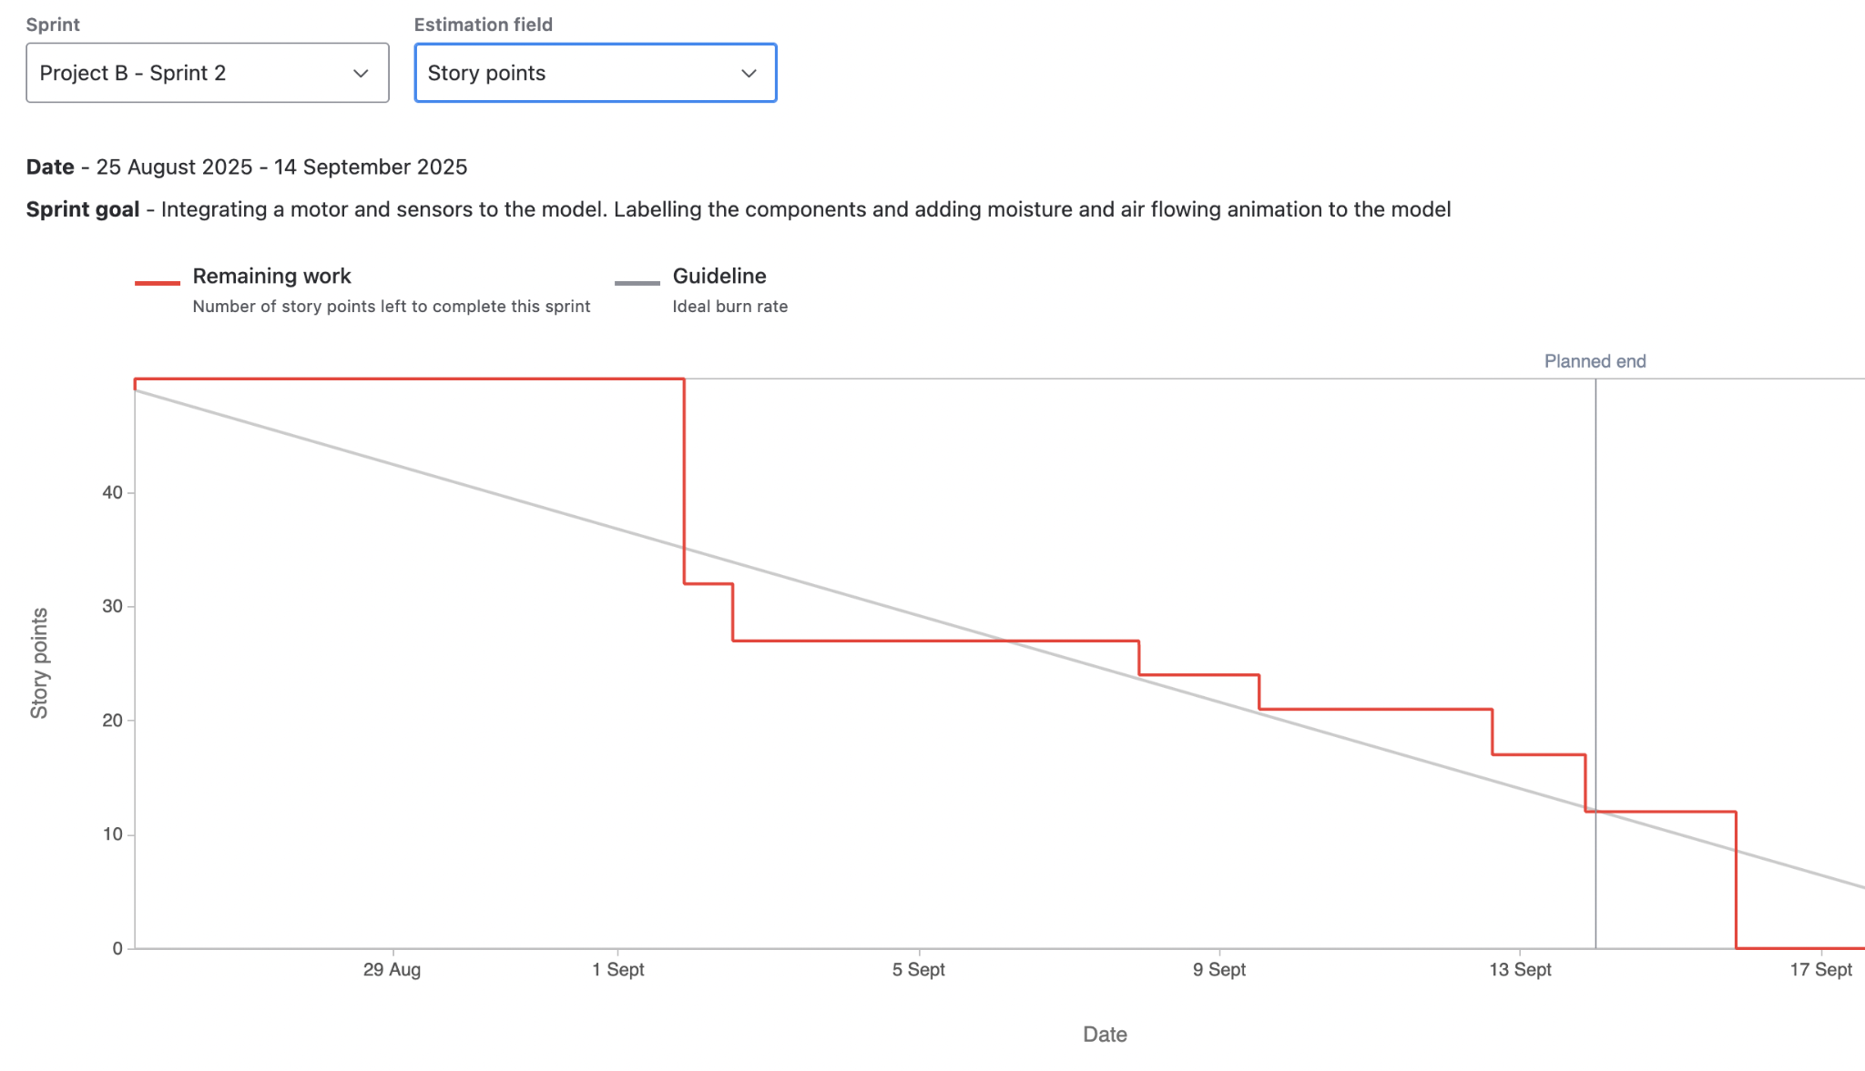
Figure 1.2 Sprint 2 Burntdown chart
The progress of Sprint 2, which officially ran from 25 August to 14 September 2025, can be visualised in the burndown chart generated from Jira. The chart tracks the remaining story points against the ideal burn rate and provides a clear picture of how tasks were managed across the sprint. At the start, the team committed to a total of seventeen backlog items, covering tasks such as pipeline adjustments, water container animation, compost drawer refinements, sensor labelling, and GLB export preparation.
The burndown chart shows that our progress was not strictly linear, which is a direct reflection of the way our team approached the work. Instead of completing tasks one by one in sequence, we often worked on several related tasks simultaneously and then marked them as complete together. For example, the refinements to the pipelines, water container animation, and sensor labels were developed in parallel, and as a result, multiple items were closed on the same day. This explains why the chart shows periods of minimal movement followed by sudden drops in remaining story points.
Another observation from the chart is that some of the backlog items were officially closed after the sprint end date of 14 September. This does not indicate delays in the technical work itself, but rather reflects the fact that while we completed all modelling, animation, and integration tasks by the sprint deadline, we continued working on report-related items during the mid-semester break. Since the Sprint 2 report submission date was set for 21 September 2025, documentation tasks such as updating contribution details, uploading Jira backlog evidence, and finalising the sprint report were carried over into that period. This accounts for the extended completion timeline visible on the burndown chart.
Despite these variations, the sprint was highly productive. All technical deliverables were completed on time, including the introduction of the tap-based drainage system, the water container animation, improved compost drawer functionality, pipeline refinements, and the preparation of GLB exports for app testing. The final backlog items related to documentation were completed shortly after, ensuring that the sprint was fully deliverable by the reporting deadline.
Overall, Sprint 2 demonstrated steady progress, even if the workflow did not follow a perfectly linear trajectory. The use of Jira to manage tasks and track story points, combined with client and facilitator meetings for continuous feedback, helped keep the sprint on track. The eventual completion of all seventeen backlog items confirms that the sprint objectives were achieved, with the only extension being linked to reporting tasks rather than technical deliverables.

sprint review (critical review of the product)
Sprint 5 Demonstration
The Sprint 2 review was held virtually using Microsoft Teams on September 9th, 2025 from 6:00 PM to 7:00 PM and included all team members as well as the client, Mr. Alex Jaimes Castillo. The demonstration session went well according to the facilitators who said that each member spoke clearly and professionally about their tasks. In particular, the demonstration contained improvements to the composter’s drainage system, the transparency of the pipes, as well as updated animations. During the session, the team highlighted two drainage options in which a knob-based option had two drainage options (knob-based and tap-based), demonstrated transparency-based features for water flow, and confirmed alignment of motors and pipes. This demonstration was interactive and any questions from the audience were addressed immediately, as well as agreement on next steps was reached collaboratively.
Key Features Shown
- Slanted chamber bottom with funnel for water drain.
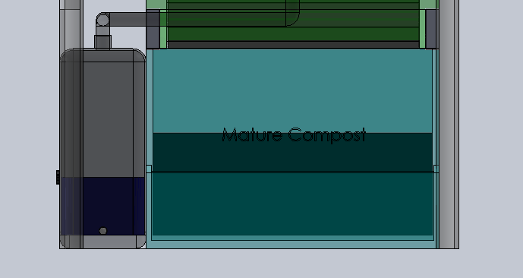
Figure 1.3 Water tank with the knob

- Motor placement for the two phases
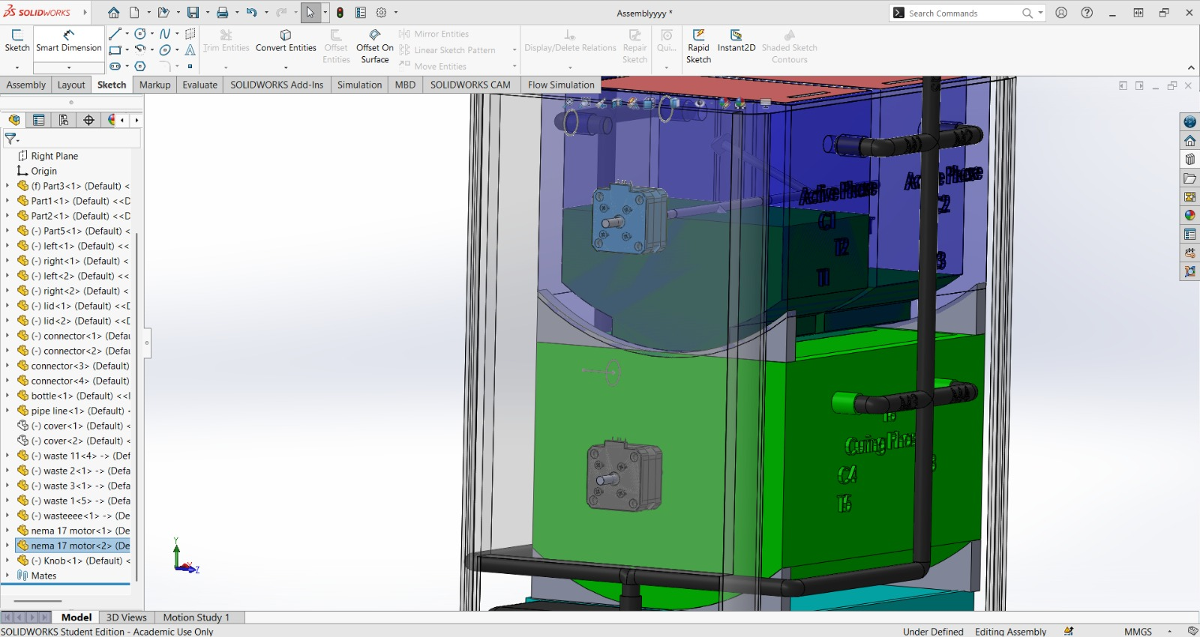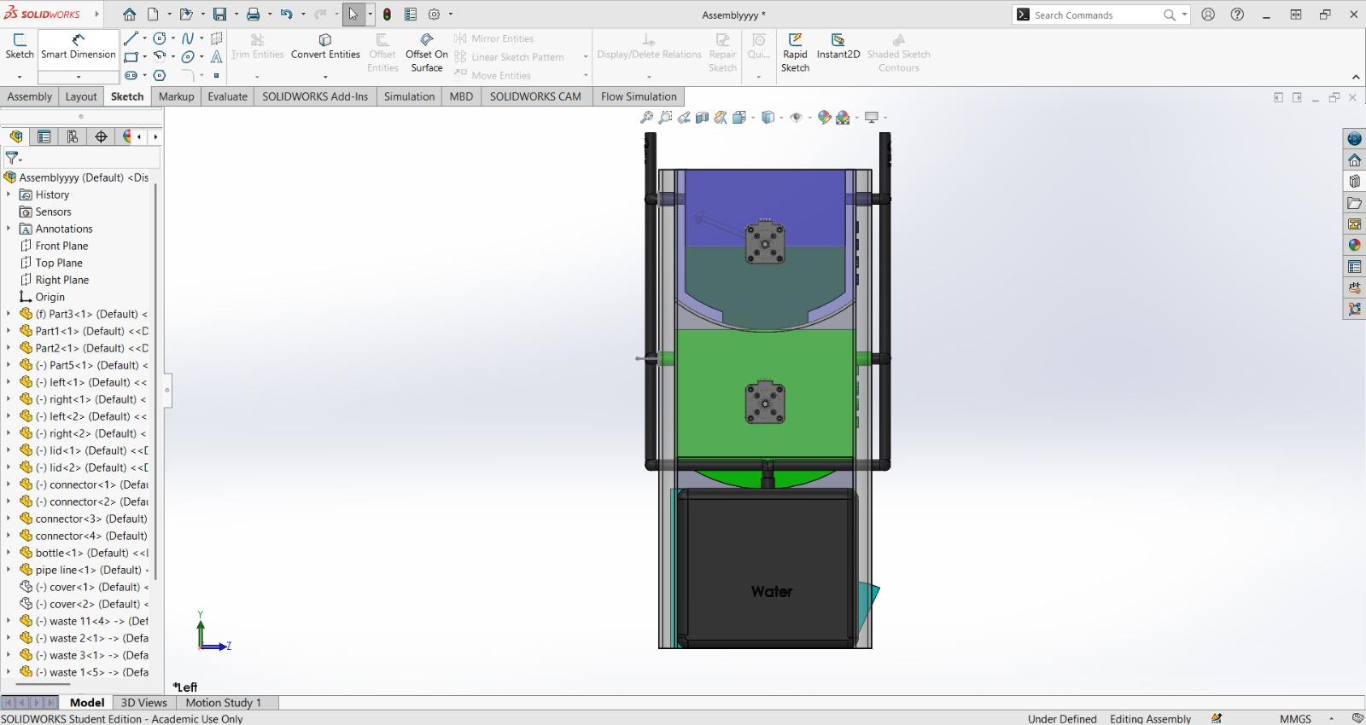
Figure 1.4 Motors for the model

- Transparent water tank animations in the model.
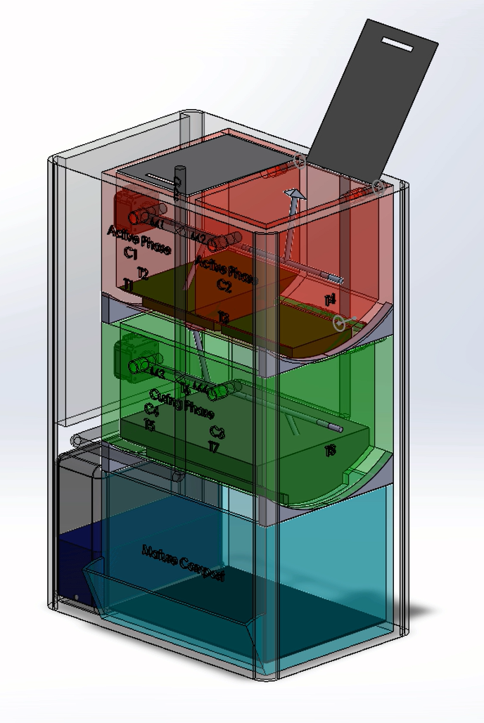
Figure 1.5 Animated version of the model
- Motor alignment and pipe alignment in the new model.
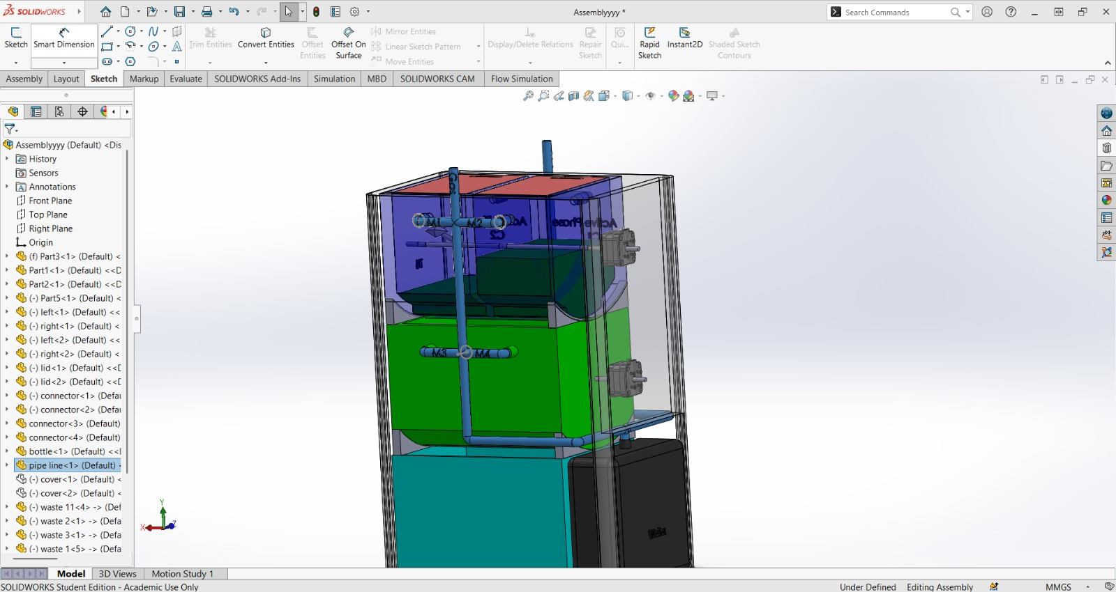
Figure 1.6 Motor and the pipe alignment
- Initial exploration of LIDA application integration with the exported GLB model.
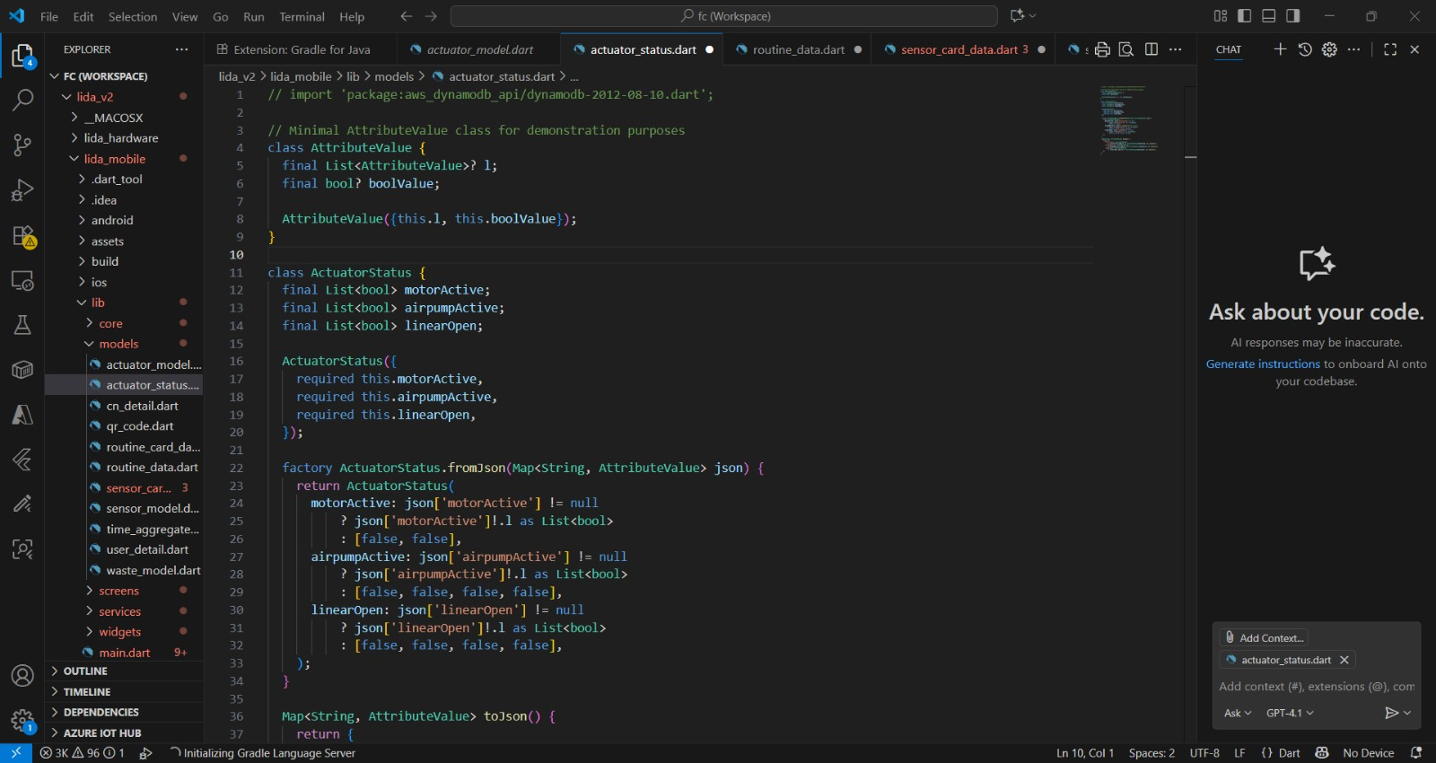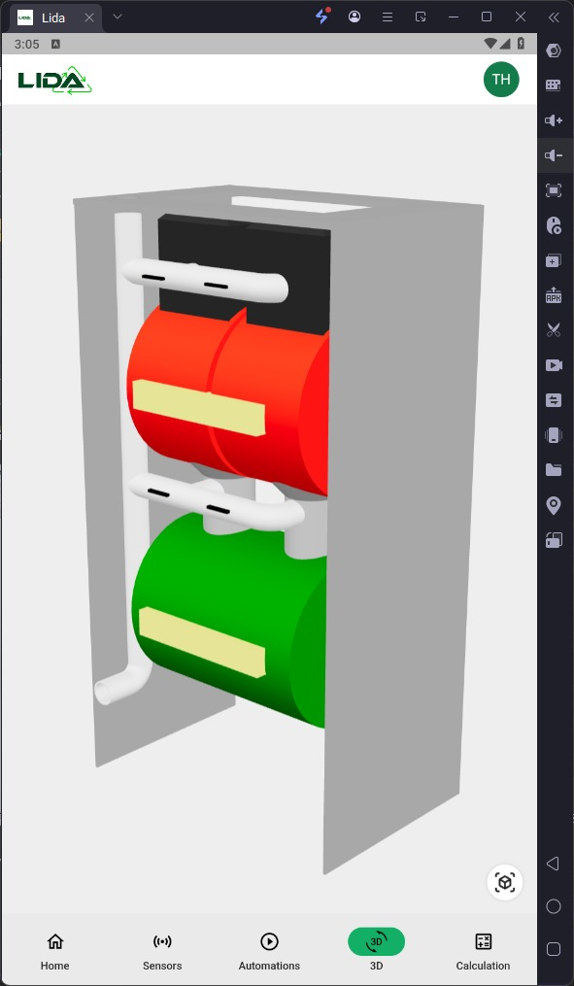
Figure 1.7 LIDA exported GLB model

- Labelling of the phases and the motors.
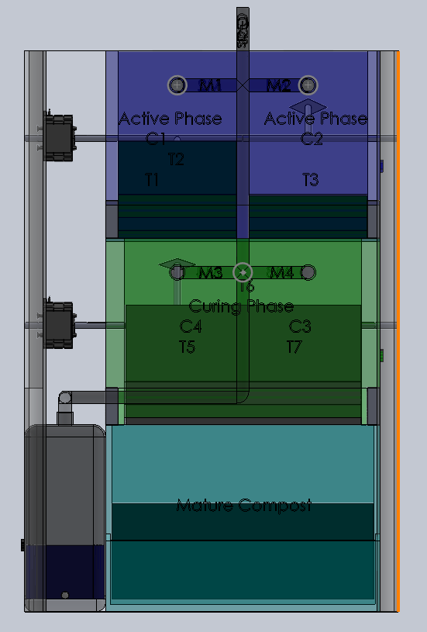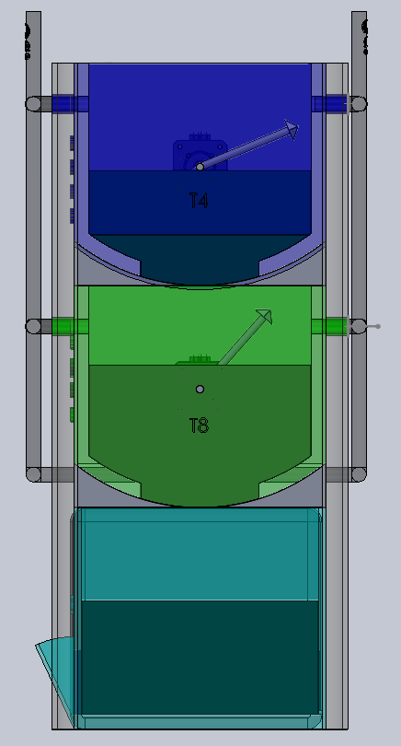
Figure 1.8 Labelling in the model
Client feedback
Mr. Jaimes Castillo stated that the Sprint 2 increment was partially deliverable. In his statement that there were really some great improvements being made, he listed the following:
- Use the tap-based mechanism instead of the knob-based one.
- Raise the water tank about 10 cm to position the tap into appropriate placement, and prevent the stagnation.
- Maintain two versions of the model, one realistic version and transparent.
- Remove the excess sketch lines for visual realism.
- Prepare the model for the application in GLB file format, and commence front-end UI preparation to display sensor data.
Progress Assessment and Reflection
Sprint 2 brought progress in tackling drainage issues and improved clarity of the model. Overall, the addition of the tap-based drainage system and corresponding transparency features were great improvements. Additionally, the decision to keep two versions of the model was beneficial; one for the realism of real-world functionality, and another for the educational attributes of testing found system issues. Overall Sprint 2 was partially deliverable. Animations for the drainage and corresponding transparency were successful. However, visual improvement of compost textures and preparation of the app for UI integration does need refinement. One risk that has made this Sprint impactful is the lack of time throughout the Sprint to gain permission to use the Flutter app that the client had provided. This will likely postpone integration at the start of the next sprint. Nonetheless, the team maintained focus in planning for a follow-up meeting with Kentai the developer from the previous Sprint and developing additional questions for the app testing. All in all Sprint 2 has shown continued steady progress toward deployment in app-ready format.
Challenges and Resolutions
Challenge | Description | Resolution
Drainage Mechanism Options | A knob causing drainage created leaks and was unrealistic. | Switched from a knob to tap with funnel drainage.
Tap Placement | Low tap created a super high risk for stagnant water at the bottom of the tank. | The next step is adding a 10 cm platform beneath the tank in sprint 3.
Visual Realism | Having all the sketch lines made it look unprofessional. | The team will work to clean up the visuals and have both a transparent (outside facing) version and a realistic (inside facing) version.
App Integration Delay | Flutter app permissions were not provided in a timely fashion. | The session with the alumni will focus on getting access issues resolved so we can move ahead with GLB testing.
Model Variants | Uncertainty if the transparent model vs the realistic one made sense | The client also confirmed that we should maintain both versions for different purposes

retrospect (critical review of the process)
Overview
All team members participated in the Sprint 2 retrospective meeting which was held online via Ms Teams on Friday 12th September 2025 from 2:00 PM to 3:30 PM. The work of Sprint 2 was reflected on by sharing the demonstration, reflecting on feedback from the client and facilitator, and reviewing strengths, weaknesses, and lessons learned. The main work to be proud of was the acceptance of the tap-based drainage system, improved animations, and the enhanced teamwork and collaboration. The main challenges for the last sprint were pipe alignment, visual realism, and delays of testing due to the permission to access Flutter app files. The discussion also moved towards planning the Sprint 3 backlog, clarifying those resistance, and preparing to integrate the app with sensor data handling.
Meeting Details
Date | Time and Venue | Attendees
12th September 2025 (Friday) | 2:00 PM – 3:30 PM, Online (MS Teams) | Chrishelle Anthoneyz, Haritha Perera, Thenura Kuruppuarachchi, Senupama Deshapriya
Retrospective
Start Doing | Stop Doing | Keep Doing
Earlier in the sprint, we worked on refining pipe layouts as well as cleaning the excess sketch lines. | We relied on late communication with external developers to integrate the app. | The work is clearly divided as shown in the individuals’ responsibilities.
Start preparing a user manual and technical documentation while developing the product. | We waited for the sprint reviews to test exports and animations. | We had frequent facilitators checks-in and were transparent in the updates and progress on Jira.
We started working on mock-ups of the UI to showcase live values from the sensors. | We allowed export permission problems to block our integration tasks. | We incorporated client comments quickly into the model.
Action Items for Upcoming Sprint
- Water Tank Platform and Tap Drainage
An additional platform for support will be inserted beneath the water tank and will need to integrate into the tap drainage system and make use of all outflows and functionality.
- Pipeline Refinement
Reconfigure the layout between the pipeline sections to smooth transitions and omit excessive sketches to improve realism, but most importantly streamline function.
- GLB Export Testing in Flutter
Once access permissions are confirmed, begin testing GLB file exports with the Flutter app and check if it works on all platforms.
- UI Integration w/alumni
Confirm mobile UI integration with alumni, mainly through determining the sensor data flow as well as the application data.
- User Manual
Start drafting a more structured user manual as well as a technical handover guide for future development and programs.
- Sensor Data UI Mock-up
Create a mobile UI mock-up to display the real-time speed sensor data as well as the temperature, gas, and moisture sensor levels.
- Sensor Labels and Models
Add labels to clarify where each sensor would be located for its use and offer both transparent and realistic versions of the models for output.

Review of Cybersecurity and Ethical Guidelines
Prior to conducting mobile integration with the consideration of handling sensor data, the team reviewed relevant cybersecurity and ethical guidelines to help ensure compliance and responsible development
- Australian Privacy Principles (APPs): Any data of the sensors (temperature, gas, moisture) will be the APPs in compliance with the APPs immediately, even when anonymised. We will not collect any personal identifiable data in any way.
- Data Security: Sensor data will be stored and transferred securely. Where possible, data will be transferred along using encrypted connections.
- Ethical Development: We will be transparent to stakeholders allowing the user the kind of data we have collected, and how it will be presented. In the user interface, we will present sensor data values correctly to not misrepresent the data.
- Testing Protocols: Any simulated or mock data presented in the development or testing of the user interface will be labelled as such so that there is no confusion for users between simulated data and the live sensors.
- Handover Documentation: The user guide and technical handover documentation will include guidance for users on how to use the system in a responsible manner and restrictions of how sensor data can be interpreted.

lessons learned (critical review of sprint two experience and future plan)
1. Pipe and Drainage Systems Need to Be Brought Together Earlier
In Sprint 2 we learned that waiting until a later portion of the sprint to align the hardware and biowaste pipe and drainage system created timing conflicts when it came to animating the model and integrating the animation. When we brought both sides together with T's it was apparent that the geometry of the airflow and condensation logic took shape. This supports the need for cohesion within structural systems, but also a cohesive aesthetic, before dealing with the visuals.
2. Removing Excessive Visuals Provides Clarity
Too many sketches of excess lines on the model created confusion throughout the design when demonstrating to the client. Cleaning and simplifying the model not only improved performance in animation, but also improved the client's interpretation of the airflow, drainage and compost stages. This supports the importance of the clarity of visuals and demonstrates an element of technical accuracy alongside aesthetics.

3. GLB Export and Mobile Testing Need to Be Occurring Concurrently
Exporting the modelling and animation into a GLB format to explore communication to the mobile application took longer because of access permissions to the app. This presented a level of risk in committing too much time in the sprint to integration tasks. Design to GLB compatibility needs to be a task happening alongside the modelling and design process unlike we did in this sprint.
4. Communication with External Stakeholders Is Required
Working with Kentai for the UI integration, designing data collected from the app, reinforced the need to have alignment with external partners early. Uncertainty in the UI expectations from those providing the hardware, had to be refined in revisions. Key learning was to have the teams communicate to establish a check-point with hardware and applications in conjunction with programming activities to not leave the feedback until the end.
5. Documentation Cannot Be Saved Until the End
The draft of users manual and technical hand-over guide started late in the sprint, creating distance from design conversations to accurately document decisions made in this period of the project. Sprint 2 reinforced the importance of documenting progress as a series of notes, so future team members (and clients) get consistent and detailed records of the entire system progress.
6. Sensors and UI Need to Have a Combined Consideration
Labeling sensors on each model and utilizing transparent vs. realistic-modelling versions to demonstrate the ID of the hardware these models would be displayed after fidelity of the data took into consideration the level of difficulty for re-fabricate and display in conjunction with the user's interface. This indicates that the process of planning the sensors in the design should be interconnected with the process of visually representing data and functionality in the final product.
Practical and Feasible Future Suggestions
Area | Recommendation | How it will be implemented
Pipe & Drainage Integration | Finalize all of the mirrored pipe connections with the same "T" joints. | Validate the pipe layout during sprint 3 check in and run condensation/airflow tests with animations.
Model Visuals | Always use the existing drawing but simplify the form. | Clean and simplify models between design cycles and before exporting them, for usage observations, and before reviews.
GLB Export & Mobile Testing | If possible, run the GLB export testing at the same time as modelling to avoid issues at the end. | Have only one person document testing of a weekly export run via the Flutter app, to ideally be testing for issues to report on weekly.
UI Collaboration | Include alumni and the hardware team earlier in the UI flow. | Plan on one sync with hardware teams weekly to develop plans for how to handle data and display sensor readings in the UI.
Documentation | Create documentation that represents a living document of updates made to the model, including logic decisions. | Incrementally update the user manual and handover manual with updates done in each sprint.
Sensor Integration | Incorporate the sensor placement with the UI design process. | Incorporate labelled placeholders within the 3D model that match labelled UI mock-ups for the app.

Plans for Next Sprint (Sprint 3)
- Finalize Pipe and Drainage Systems
- Improve Compost Drawer Animations
- Add Sensor Models and Labels
- Test Mobile Integration
- Improve UI Mock-ups
- Improve Compost Materials
- Draft Technical Handover
- Client and Hardware Meeting

